PDFID 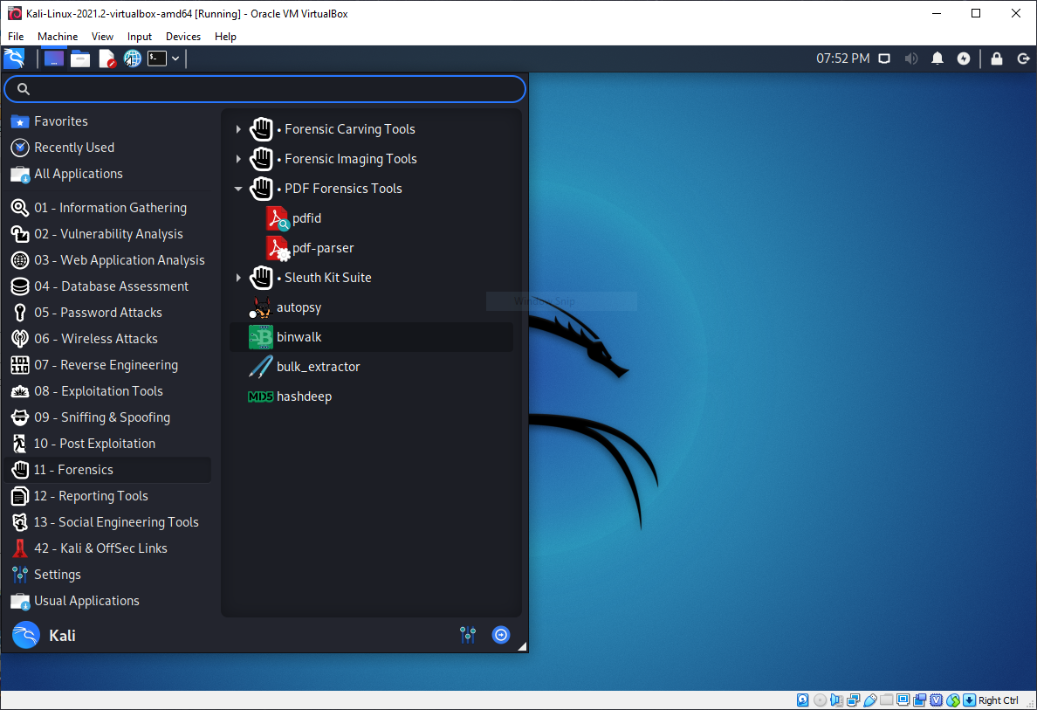

The use of PDFID allows the user to see if their pdf might have any backdoor scripts or anything else embedded into it. This is an example of a virus pdf having script to harm the user.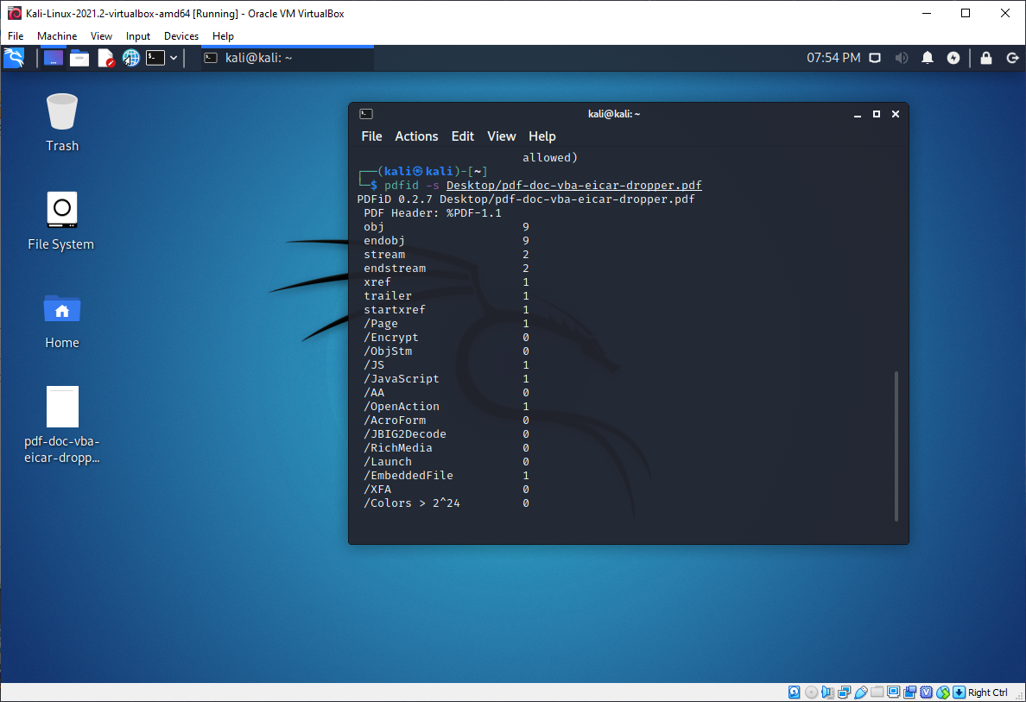

HashCat allows the hacker to be able to quickly and effectively crack the code to hash codes that contain user data.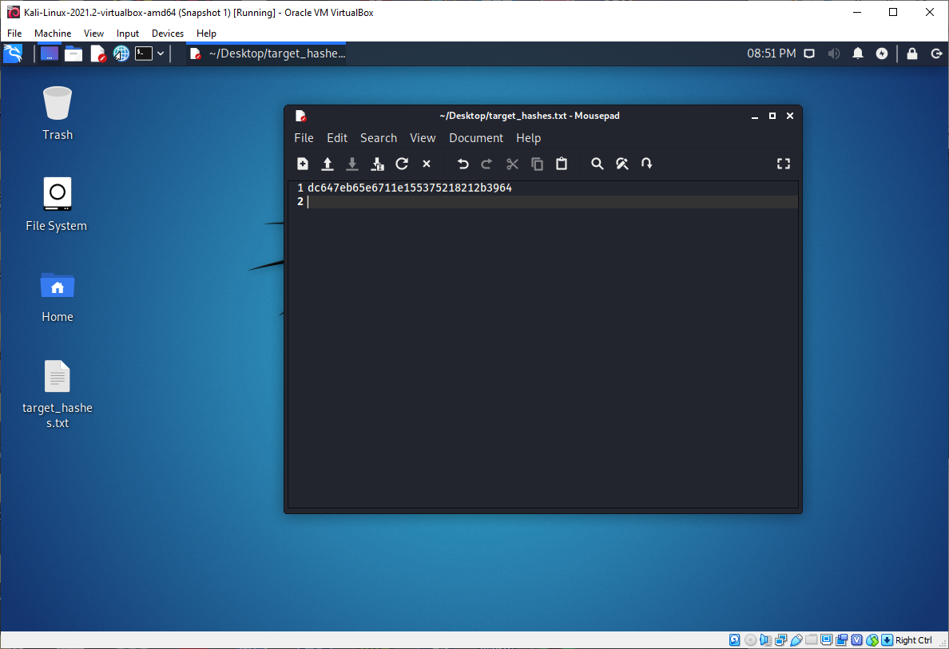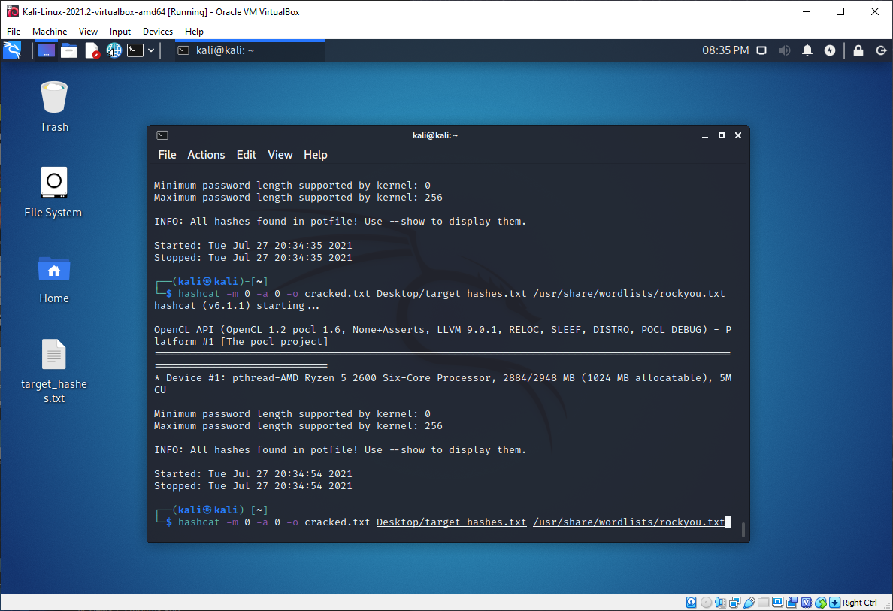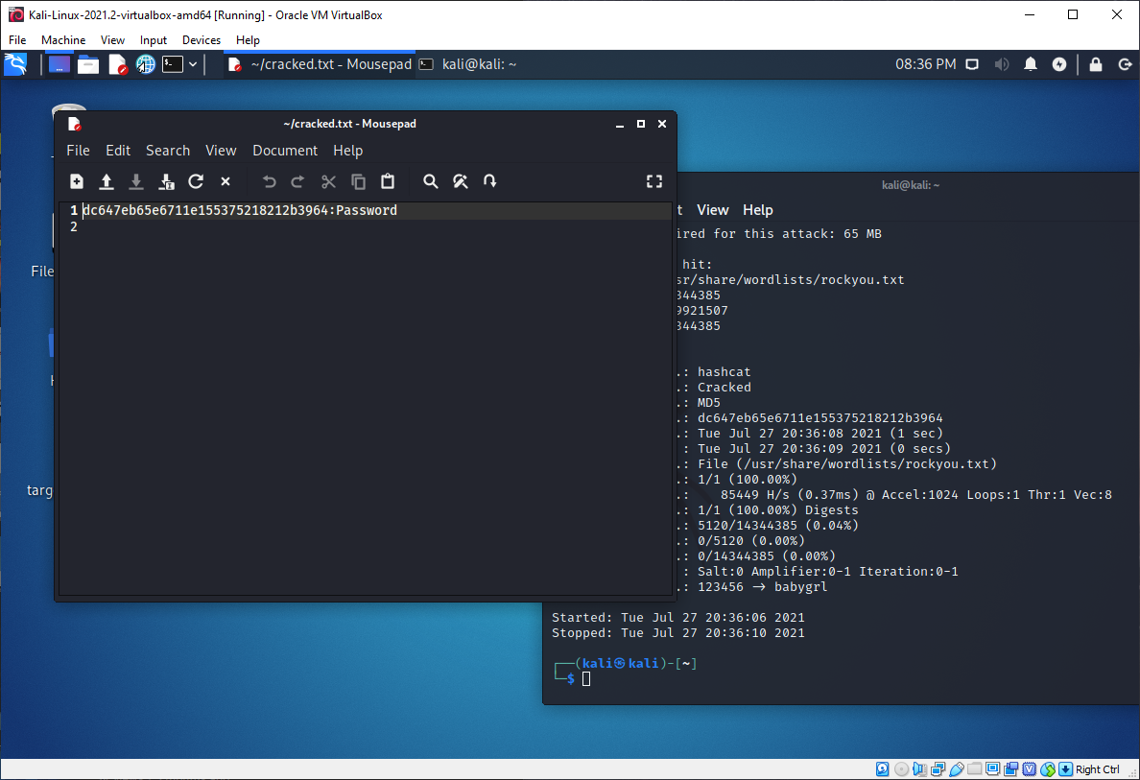

Wafw00f allows the user to find the IPS which is the Intrusion Prevention System of the website that is set by the hacker. Which got us the IPS which is Cloudflare.